WEEK 3
1# Write a java program to add the two numbers.
CODE:
package week_1;
import java.util.Scanner;
public class ADDING_TWO {
public static void main(String[] args) {
Scanner sc= new Scanner (System.in);
System.out.println("Enter two numbers: ");
int n1=sc.nextInt();
int n2=sc.nextInt();
int sum= n1+n2;
System.out.println("Sum of "+ n1 + " and " + n2 + " is " + sum);
}
}
OUTPUT:
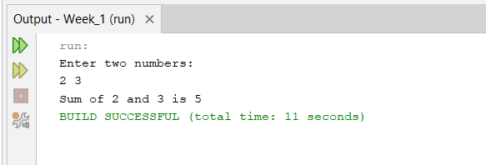
2# Write a java program to multiply two floating numbers.
CODE:
package week_1;
import java.util.Scanner;

public class Two_floating {
public static void main(String[] args) {
Scanner sc = new Scanner (System.in);
System.out.println("Enter two float numbers: ");
double n1=sc.nextDouble();
double n2=sc.nextDouble();
double product= n1*n2;
System.out.println("Product of "+ n1 + " and " + n2 + " is " + product);
}
}
OUTPUT:
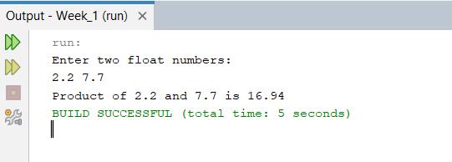

3# Write a java program to display a cube of a number.
CODE:
package week_1;
import java.util.Scanner;
public class Cube {
public static void main(String[] args) {
Scanner sc = new Scanner (System.in);
System.out.println("Enter a number: ");
double n=sc.nextDouble();
double cube= Math.pow(n, 3);
System.out.println("Cube of " + n + " is " + cube);

}
}
OUTPUT:
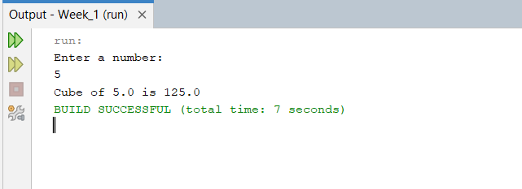

4# Write a Java program that takes three numbers as input to calculate and print the average of the numbers.
CODE:
package week_1;
import java.util.Scanner;
public class Avg {

public static void main(String[] args) {
Scanner sc= new Scanner (System.in);
System.out.println("Enter three numbers: ");
int n1=sc.nextInt();
int n2=sc.nextInt();
int n3=sc.nextInt();
double avg = (n1+n2+n3)/3.0;
System.out.println("Average = " + avg);
}
}
OUTPUT:
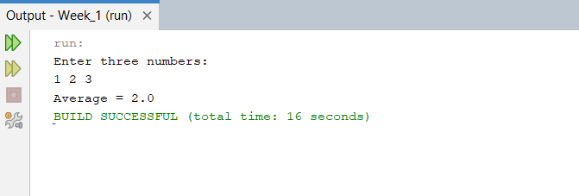

5# Write a Java program to compute the distance between two points.
CODE:
package week_1;
import java.util.Scanner;
public class Distance {

public static void main(String[] args) {
Scanner sc = new Scanner (System.in);
System.out.println("Enter first coordinates: ");
double x1 = sc.nextDouble();
double y1 = sc.nextDouble();
System.out.println("Enter second coordinates: ");
double x2 = sc.nextDouble();
double y2 = sc.nextDouble();
double distance= Math.pow((x1-x2),2) + Math.pow((y1-y2),2);
System.out.println("Distance = " + Math.sqrt(distance));

}
}

OUTPUT:
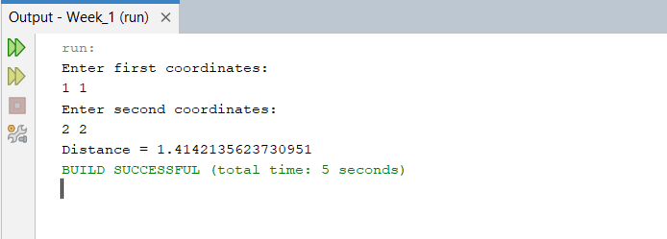

Optional
6# Write a Java program to swap two numbers using a temporary variable.
CODE:
package week_1_optional;
import java.util.Scanner;

public class Swap {
public static void main(String[] args) {
Scanner sc = new Scanner (System.in);
System.out.println("Enter two integer numbers: ");
int n1=sc.nextInt();
int n2=sc.nextInt();
System.out.println("Before swapping n1 = " + n1 + " and n2 = " + n2);
int temp= n1;
n1=n2;
n2=temp;
System.out.println("After swapping n1 = " + n1 + " and n2 = " + n2);
}
}
OUTPUT:
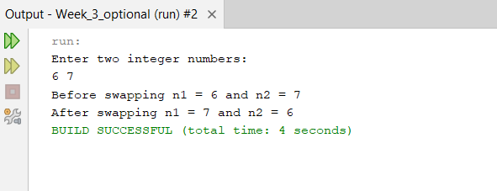
7# Write a Java program to calculate the area of a rectangle given its length and breadth.
CODE:
package week_1_optional;
import java.util.Scanner;

public class Rectangle {

public static void main(String[] args) {
Scanner sc = new Scanner (System.in);
System.out.println("Enter length and breadth: ");
double length=sc.nextDouble();
double breadth=sc.nextDouble();
double area=length*breadth;
System.out.println("Area of rectangle = " + area);
}
}
OUTPUT:
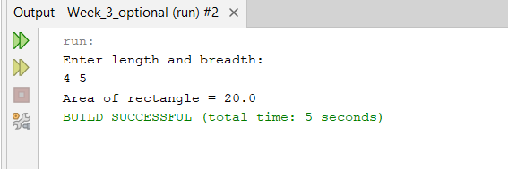

8# Write a Java program to convert temperature from Celsius to Fahrenheit.
CODE:
package week_1_optional;
import java.util.Scanner;

public class Celcius_Fahrenheit {

public static void main(String[] args) {
Scanner sc= new Scanner (System.in);
System.out.println("Enter temperature in Celsius: ");
double c=sc.nextDouble();
double f=((9.0/5.0)*c)+32;
System.out.println("Temperature in Fahrenheit is " + f);
}
}
OUTPUT:
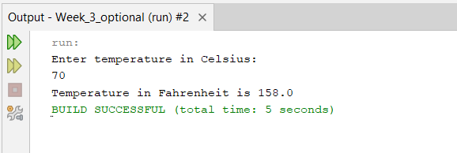

9# Write a Java program that takes two integer inputs and computes their remainder and quotient.
CODE:
package week_1_optional;
import java.util.Scanner;
class Remainder_quotient {
public static void main(String[] args) {
Scanner sc= new Scanner (System.in);
System.out.println("Enter two integer values: ");
int n1=sc.nextInt();
int n2=sc.nextInt();
System.out.println("Reaminder = " + (n1%n2) + " and Quotient = " + (n1/n2));}}
OUTPUT:
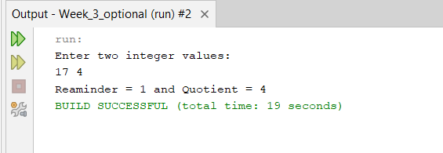
10# Write a Java program to find the circumference of a circle given its radius.
CODE:
package week_1_optional;
import java.util.Scanner;

public class Circumfrence {
public static void main(String[] args) {
Scanner sc= new Scanner (System.in);
System.out.println("Enter radius: ");
double r= sc.nextDouble();
double c= 2*Math.PI*r;
System.out.println("Circumference = " + c);
}
}

OUTPUT:
